
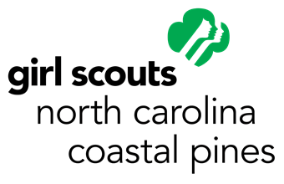
Girl Scouts – North Carolina Coastal Pines
6901 Pinecrest Road
Raleigh, NC 27613
1-800-284-4475
patchprogram@nccoastalpines.org

North Carolina Lighthouses:

A Girl Scout
Patch Program
For
Girl Scout Brownies, Juniors, Cadettes, Seniors, and Ambassadors

North Carolina Lighthouses
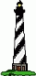

Over a hundred years ago, ships traveling along the North Carolina coast encountered dangerous shoals and storms. Hundreds of shipwrecks occurred due to the dangers of this area. The North Carolina lighthouses helped the mariners navigate the area known as the "Graveyard of the Atlantic". Today, the ships traveling the coast use modern tools, however, the lighthouses continue to operate as a reminder of the hardships encountered by our ancestors to help settle the country. The North Carolina lighthouses stand as pieces of our past. The purpose of this patch program is to educate Girl Scouts about lighthouse history and the preservation efforts to maintain them.

Activities:

- Girl Scout Brownies and Juniors must complete 2 activities from each section (Discover, Connect, and Take Action) and the 2 required activities.

- Girl Scout Cadettes, Seniors, and Ambassadors must complete 3 activities from each section (Discover, Connect, and Take Action) and the 2 required activities.

This patch program was originally written by Elaine Waters, Girl Scout Troop #184. It has since been updated to fit with GSUSA curriculum. We thank Elaine for creating this patch program.

Originally adapted from Lighthouse Brownie Girl Scout Try-It, Lighthouse Junior Girl Scout Proficiency Badge and Lighthouse Interest Project Award, Girl Scouts of Delaware-Ruritan, East Brunswick, NJ

Required Activities:
- Name all of the North Carolina lighthouses and locate them on a map. (in Resource Section)

- Identify each of the following lighthouses: (write their names below the image)

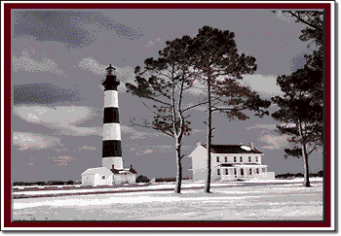
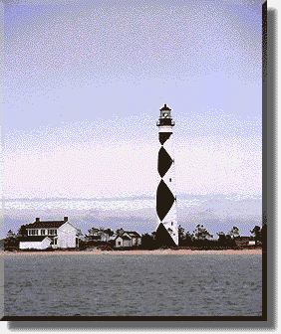
b.
c.
a.
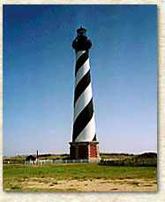

d.
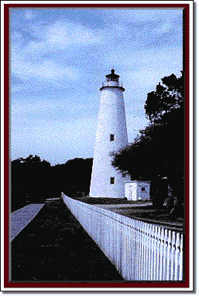
e.
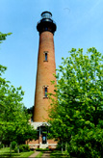

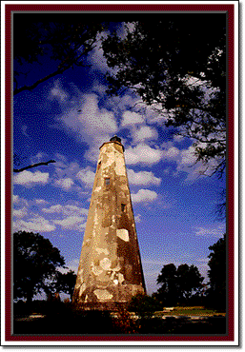

g.
f.
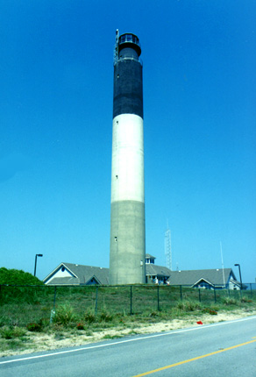

a. Photography © Bruce Roberts - Outer Banks Lighthouse Society
b. Photography © Gary & Debbie Presley
c. Cape Hatteras National Seashore
d. Photography © Bruce Roberts - Outer Banks Lighthouse Society
e. Copyright © 1998 G. L. Marler and J. A. Marler
f. Photography © J.B. Ruffin
g. Copyright © 1998 G. L. Marler and J. A. Marler

Discover

- Find the answer to the following questions:
  - Which was the tallest lighthouse in the U.S.?
  - Which is the oldest lighthouse in NC?
  - Which lighthouse is made from cement with the colors mixed in and is not painted?
  - Which lighthouse warns ships of the area known as the “graveyard of the Atlantic”?
  - Which lighthouse replaced one destroyed during the Civil War?

- Learn when and where the first lighthouse was built in the United States?

- If you were a sailor, name two ways you would distinguish one lighthouse from another at night?

- Find out about the different lenses used in lighthouses and how they work.

- Learn why lighthouses are painted differently.

- Find a sailor or pirate song and create a dance or hand motions to the song. An example of a sailor song is “A Sailor went to Sea.”

Connect
- List at least three other states that have lighthouses and learn about a lighthouse in that state.

- Read a story about lighthouses.

- Find out about the Outer Banks Lighthouse Society. Learn about what they do and their preservation efforts.

- Research the National Historic Lighthouse Preservation Act of 2000. Learn how the act impacted the Currituck Beach Lighthouse.

- Learn about a female lighthouse keeper from the past. Share with your troop what you learned.

- Learn about the duties of the lighthouse keeper. List 5 duties. Journal about whether you would want to be a lighthouse keeper.

- What are 3 other Maritime careers?

Take Action

- Visit a lighthouse.

- Look at pictures of lighthouses. Then design your own lighthouse: make a model of it or draw your lighthouse and paint it.

- Share what you have learned about lighthouses past and present with another troop.

- Make a display about what the Outer Banks Lighthouse Society does. Display it at your school or local library.

- Take part in a program that helps to reduce shore erosion.

- Contact the lighthouse that you are interested in and ask them what type of service is needed.

- Contact the Outer Banks Lighthouse Society and volunteer to help; if you can’t visit, learn about remote volunteer opportunities.

Resources

Web sites:
http://www.visitnc.com/story/coastal-lighthouses
http://www.outerbankslighthousesociety.org/index.html
http://www.cr.nps.gov/maritime/ltshipmain.htm
http://www.lighthousefriends.com/pull-state.asp?state=NC
http://www.maritimejobs.com
http://www.lighthousefoundation.org
http://www.uslhs.org
http://www.unc.edu/~rowlett/lighthouse/nc.htm
http://www.carolinalights.com/

Books

Stick, David, North Carolina Lighthouses, North Carolina Division of Archives and History, 1980

Zepke, Terrance, Lighthouses of the Carolinas, Pineapple Press, Sarasota, FL 1998

Please send any resources you find to patchprogram@nccoastalpines.org

MAP

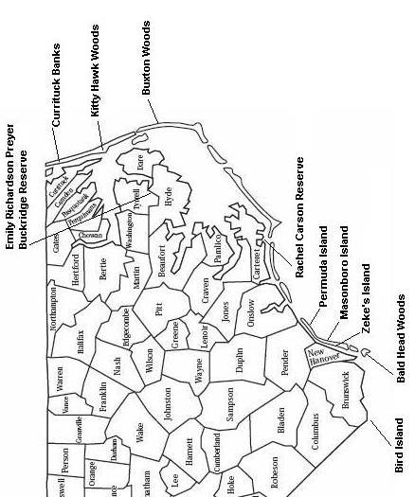

LightHOUSE Patch program Evaluation and patch REQUEST

Thank you for taking the time to complete this evaluation form. The responses given from participants are used to help plan and enhance future programs. Please complete the form by sharing your thoughts with us. Please have the girls vote and have an adult record their responses.

Tell Us About Your Troop (If an individual girl worked on the program, please indicate):
Individually Registered Girl Scout’s Name and Grade Level: __________________________________
Troop Number or Juliette: _______________
Leader and Phone/Email: ________________
Please circle your Girl Scout level and indicate the number of girls and adults who worked on this patch program on each line:
Daisy_______ Brownie _______Junior______ Cadette______ Senior_______ Ambassador______ Adult
Please check the response that best describes what your troop thinks.
Question | Strongly agree | Agree | Uncertain | Disagree | Strongly disagree
The information and activities in this patch program were interesting to us.
The activities in this patch program helped to celebrate Girl Scout Birthday Week.
We enjoyed the Girl Scout Spirit Week Days.
We learned more about Girl Scout traditions through this patch program.

What did your troop like best about this patch program?

What about this patch program could be improved?

Please list and comment on the activities you did for each part of the program.
DISCOVER
CONNECT
TAKE ACTION

Other comments or ideas to improve the program?

Order form on the next page

LightHOUSE Patch program Evaluation and patch REQUEST
Please return this evaluation to:

Girl Scouts – North Carolina Coastal Pines Raleigh Service Center Attn: Program Director – Patch Programs 6901 Pinecrest Rd Raleigh, NC 27613

If paying by check, please make all checks payable to GS-NCCP

Mail patches to:
Name:
Troop number:
Address:
Phone number:
NC Sales tax (6.75% of subtotal): __________________________________________
Total # of patches _____ x $2.00 per patch:
Shipping and handling: ______________________________________________________
Total amount paid (patches, taxes, shipping):______________________________________
Purchase Amount | Shipping Charge | Purchase Amount | Shipping Charge
Up to $25.00 | $ 2.95 | $100.01 to $200.00 | $ 14.95
$25.01 to $75.00 | $ 5.95 | $200.01 to $300.00 | $ 20.95
$75.01 to $100.00 | $ 7.95 | $300.01 to $500.00 | $ 25.95
 |  | Over $500.00 | $ 45.95

If you have any questions about content of patch program, shipping, or anything else related to the patch program, please email patchprogram@nccoastalpines.org.

